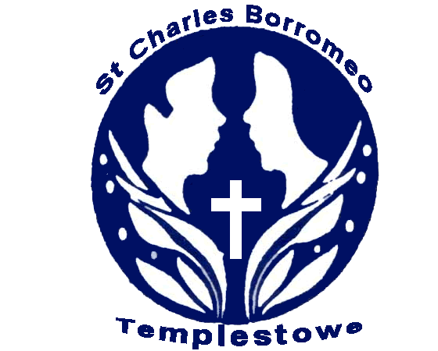
ST.CHARLES BORROMEO
230 - 234 SERPELLS ROAD, TEMPLESTOWE 3106
Telephone: 9842 7634 Fax: 9841 5427 principal@scbtemplestowe.catholic.edu.au

SUNSMART POLICY

Rationale:

A healthy balance of ultraviolet radiation (UV) exposure is important for health. Too much of the sun’s UV can cause sunburn, skin and eye damage and skin cancer. Too little UV from the sun can lead to low vitamin D levels.

As sunburn and long term exposure to ultra violet radiation, especially during childhood, heightens the risk factor for developing skin cancer later in adult life, students need to be protected from the harmful rays of the sun.

Adult guidance and encouragement should be available to assist young people in making healthy and lasting behavioural choices. This Sun Smart policy is to guide in the implementation of programs and safe behavioural throughout the year, with a combination of sun protection measures used from September to the end of April.

GUIDELINES:
• To increase student and community awareness of skin cancer risks and of practical means of protection.
• To develop strategies with encourage responsible decision making about skin protection.
• To work towards a school environment which provides shade for students and teachers.
• To ensure all students and staff wear protective clothing and broad brimmed hats for all outdoor activities.
• To incorporate educational programs on skin cancer prevention into the school curriculum and provide safety hints to the wider community.

Staff are encouraged to access the daily SunSmart UV Alert at sunsmart.com.au (or on their own school website) to find out daily sun protection times to assist with the implementation of this policy.

IMPLEMENTATION:
Parent will be:
• Informed of the Sun Smart policy.
• Be expected to purchase a broad brimmed school hat for their child to be used
during all outdoor activities from September to April
• Be expected to provide a SPF 30+ broad spectrum, water resistant sunscreen for their child's use

GENERAL:

From September to April in Victoria

When average UV Index levels reach 3 and above, a combination of sun protection measures are used whenever outdoors including:
- Teachers and children will be expected t practice sun protective behaviour.
- All children to partake in an educational program that will raise the awareness of the risk of exposure to the sun and explore safe behavioural choices, especially during term 1 & 4.
- Broad brimmed hats must be worn by both children and teachers alike, during all outdoor activities
- Outdoor activities should when at all possible, be scheduled during the morning period.

- Sun protective clothing is included in our school uniform / dress code and sports uniform. School clothing is cool, loose fitting and made of densely woven fabric. It includes shirts with collars and longer sleeves, longer style dresses and shorts and rash vests or t-shirts for outdoor swimming.
- Strategies are in place to remind students to apply sunscreen before going outdoors (e.g. reminder notices, sunscreen monitors, sunscreen buddies).
- The school council makes sure there is a sufficient number of shelters and trees providing shade in the school grounds particularly in areas where students congregate e.g. lunch, canteen, outdoor lesson areas and popular play areas.
- The availability of shade is considered when planning excursions and all other outdoor activities.
- Students are encouraged to use available areas of shade when outside.
- Students who do not have appropriate hats or outdoor clothing are asked to play in the shade or a suitable area protected from the sun.

From May to August in Victoria
When average UV Index levels are below 3, sun protection measures are not used from May until August unless in alpine regions, near highly reflective surfaces such as snow or outside for extended periods.

As part of OHS UV risk controls and role-modelling, when the UV is 3 and above staff:
- wear sun protective hats, clothing and sunglasses when outside
- apply SPF 30+ broad spectrum, water resistant sunscreen
- seek shade whenever possible

Evaluation:
This policy will be reviewed as part of the school's four-year review cycle or as required.

25 June 2011

